# A REPORT OF THE COMMUNITY HEALTH OUTREACH CARRIED OUT BY THE COVENANT APPLIED INFORMATICS AND COMMUNICATION AFRICA CENTRE OF EXCELLENCE (CAPIC-ACE) IN PARTNERSHIP WITH THE COVENANT UNIVERSITY COMMUNITY IMPACT INITIATIVE COMMITTEE (CU-CDIIC) AND ADO/ODO-OTA LOCAL GOVERNMENT HELD ON THE 25TH APRIL 2024 AT THE IJU PRIMARY HEALTH CARE CENTRE.

# INTRODUCTION

Nigeria accounts for 27% of global cases of malaria and 31% of malaria-associated deaths globally. Thus, it has the highest burden of malaria globally. In a bid to commemorate World Malaria Day, a one-day health outreach was planned for the Iju Primary Health Centre, Iju, Ado Odo/Ota Local Government. This health outreach was held on the 25th of April 2025 in the health centre premises. The Centre (CApIC-ACE) in collaboration with other bodies in Covenant University as well as the Ado Odo/Ota Local Government, bought different kinds of drugs, malaria testing kits, blood pressure and blood sugar testing kits as well as blood sample collection for laboratory molecular testing for the residents of Iju Ado Odo/Ota Local Government.

Prior to the event, the Chairman, Ado Odo/Ota Local Government, Medical director, Local government health educator and Malaria Vocal person for the Local government, were formally informed through a letter from the Vice-Chancellor and CApIC-ACE centre leader to inform them and seek their support for the event. The Event commenced at 8 a.m. on the dot with registration of participants and the assignment of Numbers to the participants. Prof. Akinnola Olayemi, the head of the malaria research group at CAPIC-ACE, was in attendance, and she flagged off the program by briefly highlighting what it entails. She also introduced the partners that came with the CApIC-ACE team, which included members of the Covenant University Medical Centre, members of the Covenant University Community Impact Initiative Committee (CU-CDIIC) team and the members of the Federated Genomic (FEDGEN) team. This was done in the presence of key personnel and stakeholders in the Ado Odo/Ota Local Government Medical team.

The outreach commenced with health talks, Malaria prevention Talks from the Ado Odo/Ota Local Government Medical team, CU medical team and the Covenant University Community Impact Initiative Committee (CU-CDIIC) team. The team from the Federated Genomic Labs at CApIC-ACE introduced the CApIC-ACE FEDGEN PHIS (Public Health Information System), a platform designed to enhance public health literacy by incorporating text-to-text and text-to-speech language translation services, making health information accessible to Indigenous communities in multiple languages. After the health talk, research associates of the Centre promptly escorted the participants from the Tent set or the health talk to where consultations and testing were to take place, with priority given to pregnant women, the elderly and children under five. The testing began with the participants' vitals being taken after they presented their tally numbers. After this, free malaria parasite screening, free medical consultation, and free treatment and drug administration, where necessary, were carried out. Residents of Iju Community who faced other health challenges aside from malaria were also attended to and drugs administered according to the prescription of the medical doctors on the ground. The test results were also shared with the participants, while mosquito nets and replants were also given to some participants.

Over three hundred community members were present and were attended to during the World Malaria Day outreach. Malaria testing using Rapid Kits. The participants were mainly women and children. The participants partook in the malaria testing. However, further molecular and microscopy testing will be conducted on all collected blood samples. Common ailments seen in adults, malaria, cardiovascular diseases, pulmonary infections, and chronic conditions such as hypertension and joint pains were the most common. At the same time, it was mainly rashes and upper respiratory tract infections in children, characterised by common complaints of cough and catarrh. A considerable number of the pregnant women had Malaria in pregnancy.

The community expressed deep gratitude to the Centre and its partners. Also, it was suggested that this kind of outreach be done more frequently in the community and other communities in the local government. The outreach was a huge success and was made possible because of the support from Ado Odo/Ota Local Government Medical team, CU medical team, the Covenant University Community Impact Initiative Committee (CU-CDIIC) team, CApIC-ACE, and the host community. Sincere appreciation goes to all partners for their support, especially the Vice Chancellor of Covenant University, Prof Anake Williams and CApIC-ACE centre leader, Prof. Emeka Iweala, for showing tremendous leadership in making this outreach a huge success.

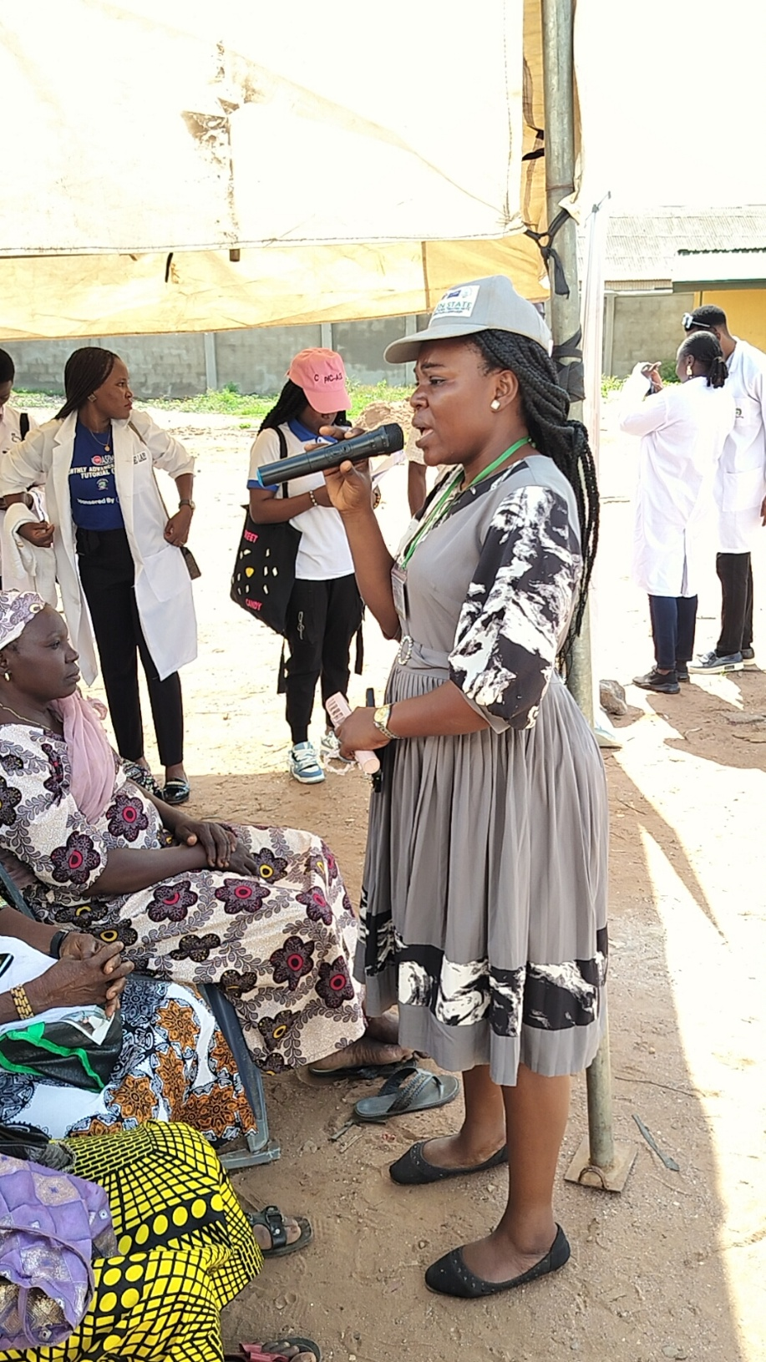

**Photo Speaks: The Malaria Vocal Person Ado Odo/Ota Local Government, Mrs Solomon, giving Malaria prevention Talks to the participants.**

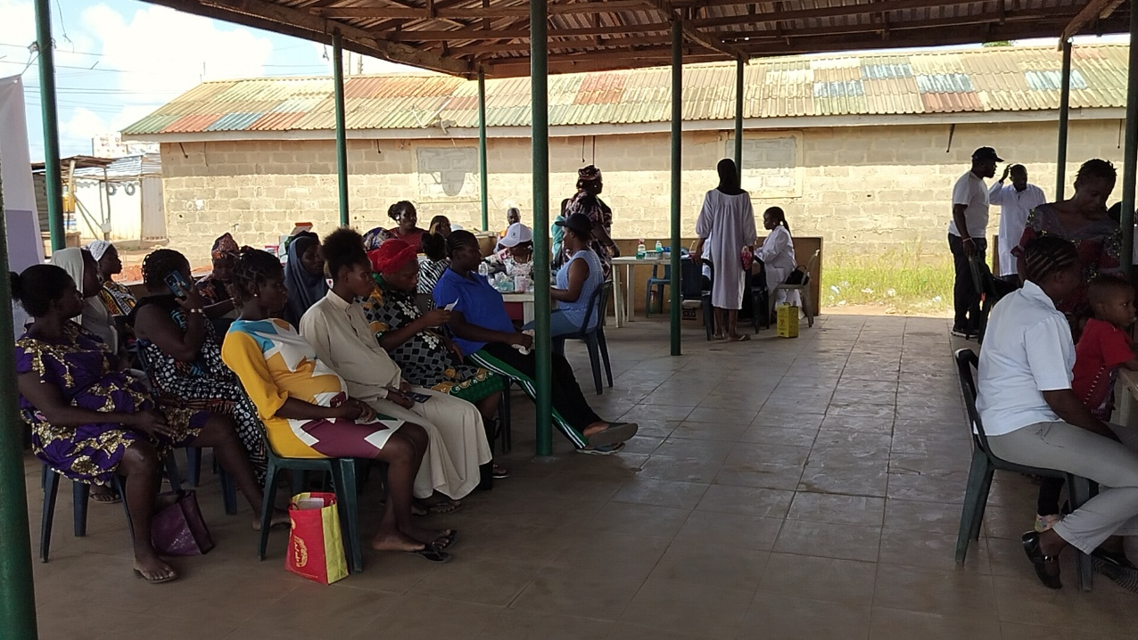

**Photo Speaks: A cross-section of pregnant women, waiting to be registered and tested.**

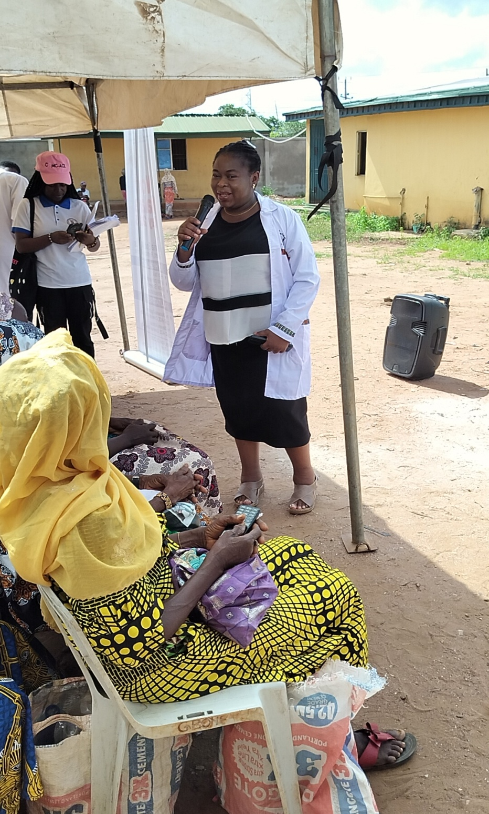

**Photo Speaks: The Head of the Malaria Research Team, CApIC-ACE Prof Olayemi Akinnola, opening the program and giving Health Talks to the participants.**

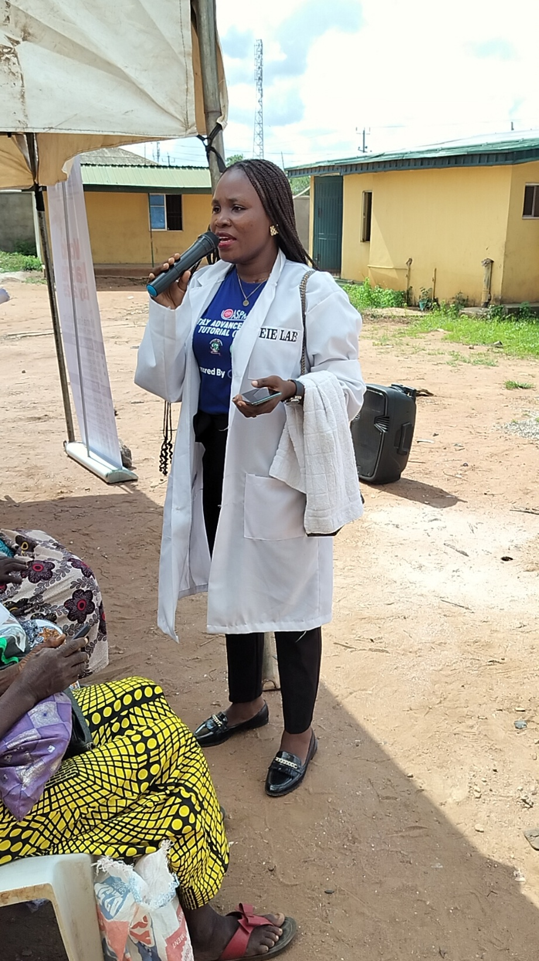

**Photo Speaks: A representative of the Federated Genomic Labs at CApIC-ACE introducing the CApIC-ACE FEDGEN PHIS (Public Health Information System).**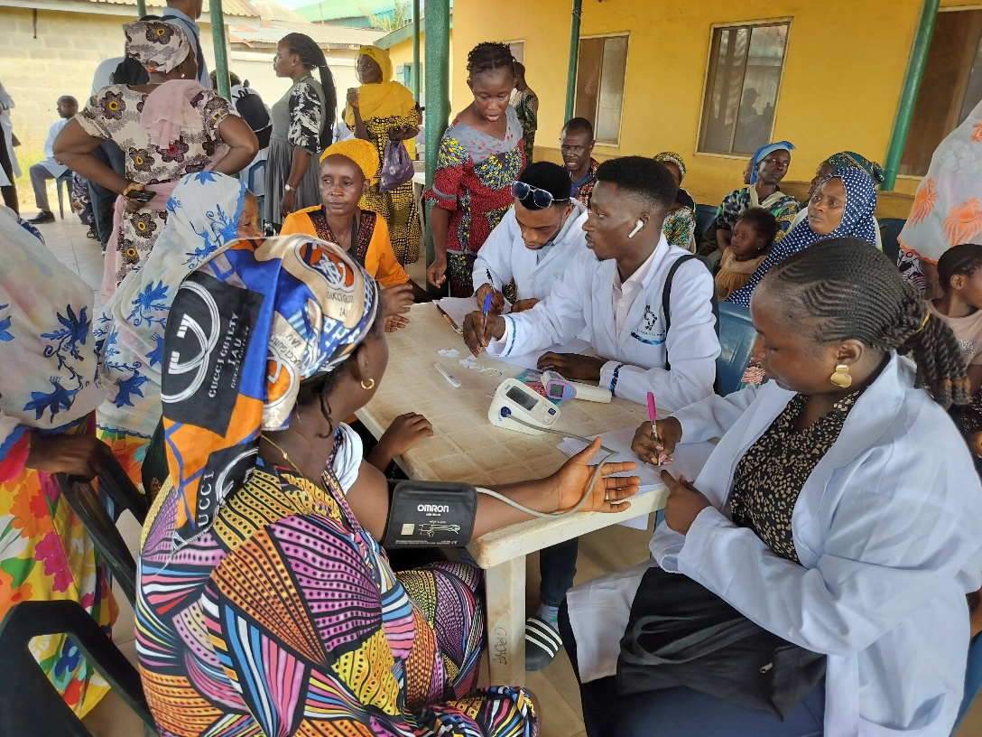

**Photo Speaks: Registration of participants.**

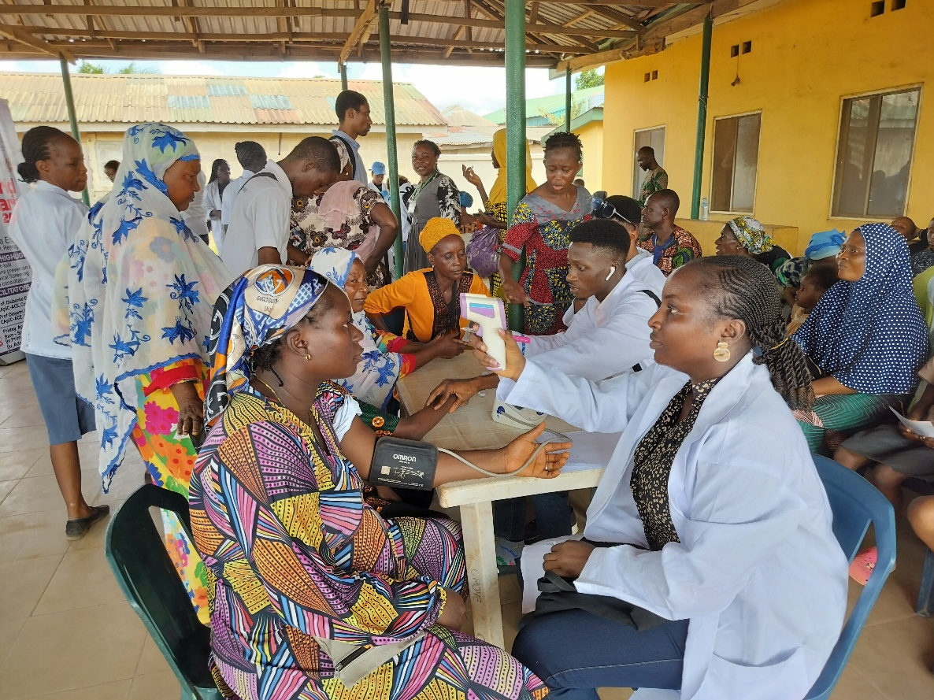

**Photo Speaks: Registration and Vital testing of participants.**

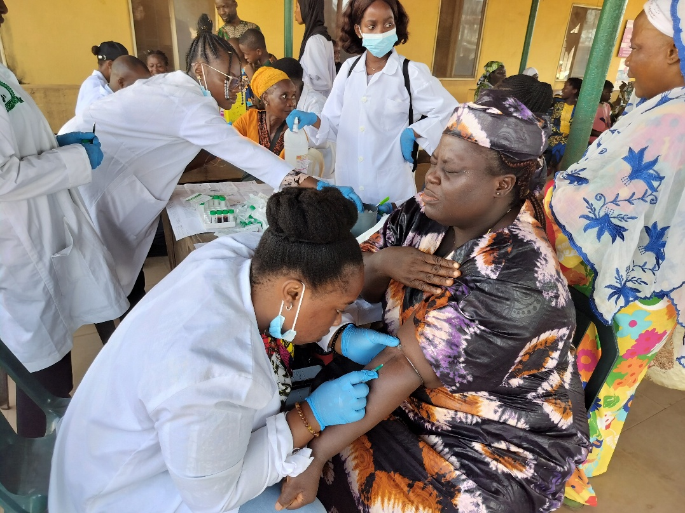

**Photo Speaks: A CApIC-ACE Research associate is collecting blood samples from participants for malaria testing.**

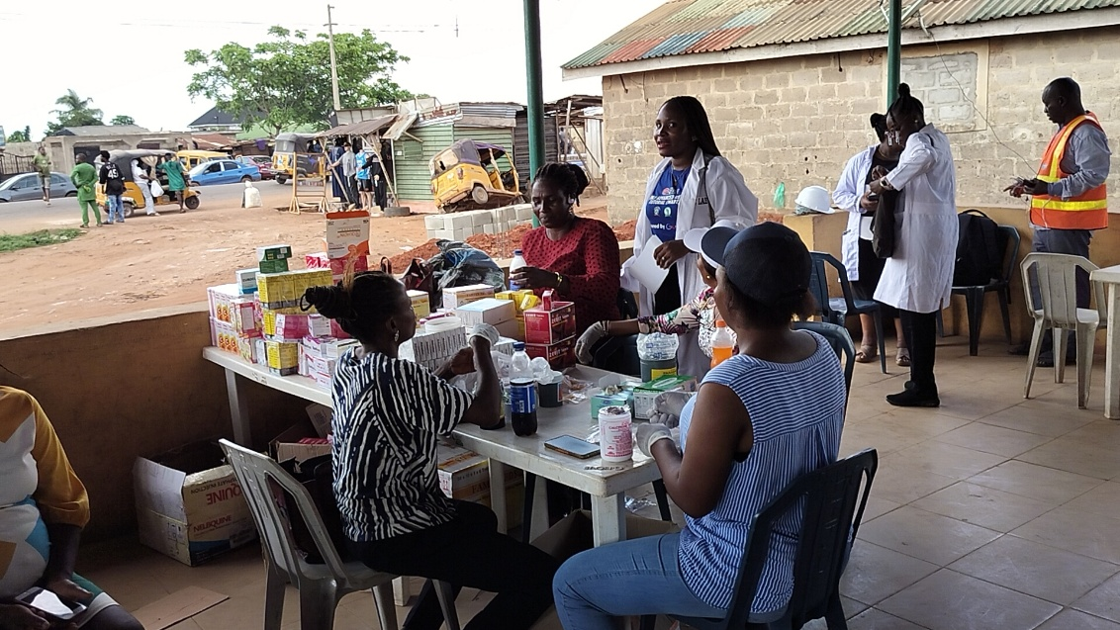

**Photo Speaks: CU Medical Centre staff dispense drugs after medical tests and consultation.**